**WEB ENGINEERING Course Instructor: Razi Ahmed Date: 19-01-2018 LAB 13 JavaServerPages and AJAX**

**Note:**

* Student collaboration is not allowed.
* Copying from or looking at solutions from other sources is strictly prohibited.
* Violations will not be excused and may result in an F in the course.
* Stay honest.

**Task1 [20]:**

Create a **login page** that contain text fields for Name and Password. When the User tries to login verify it from the **User Table** saved in Database. If user exists in table, direct it to another page which shows the link of “**Display Contact**” and **Welcome Message** to User. When link is clicked, display the Contact Name, Email and Phone Number of that Particular User from the **Contact Table** saved in Database. If User does not exist, direct him to **Sign up Page** which contain text fields for first name, last name, and password and login name and save data into User Table. Use **JavaBean** in your Java Server Pages.

**Sign Up Page:**

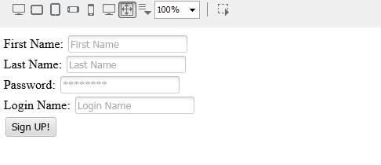

1. **Login Page:**

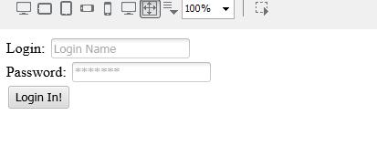

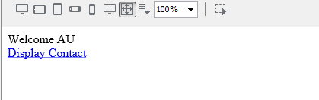

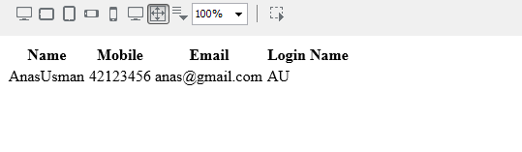

**Task2 [30]:**

Design an HTML/JSP page that takes two inputs

* Student Name
* Select Province from drop down menu

1. Punjab
2. KPK
3. Baluchistan
4. Sindh

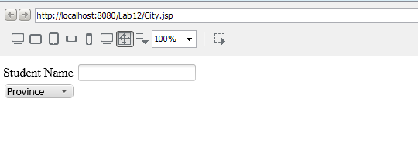

Populate the City drop down menu as per Selected Province by asynchronously calling the Servlet name GETCITIES.

Write Code for Servlet named GETCITIES. In this Servlet call the given class method named getCity(String province).

Hint: Public static ArrayList<String > getCity(String country)

